Jayant Kumar

[Jayantk237@gmail.com](mailto:Jayantk237@gmail.com)

**Front-end Design using HTML,CSS and Bootstrap**

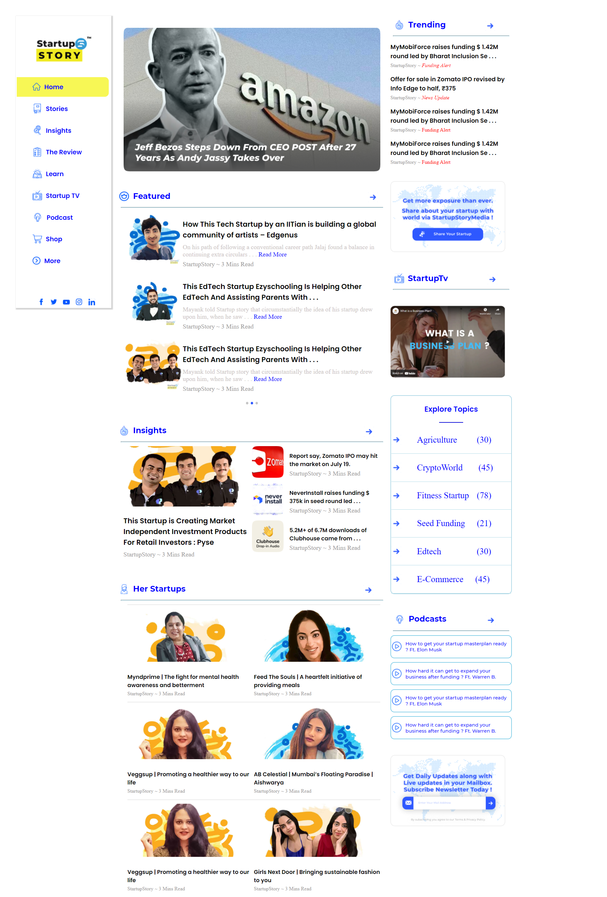

1st page design

2nd page design

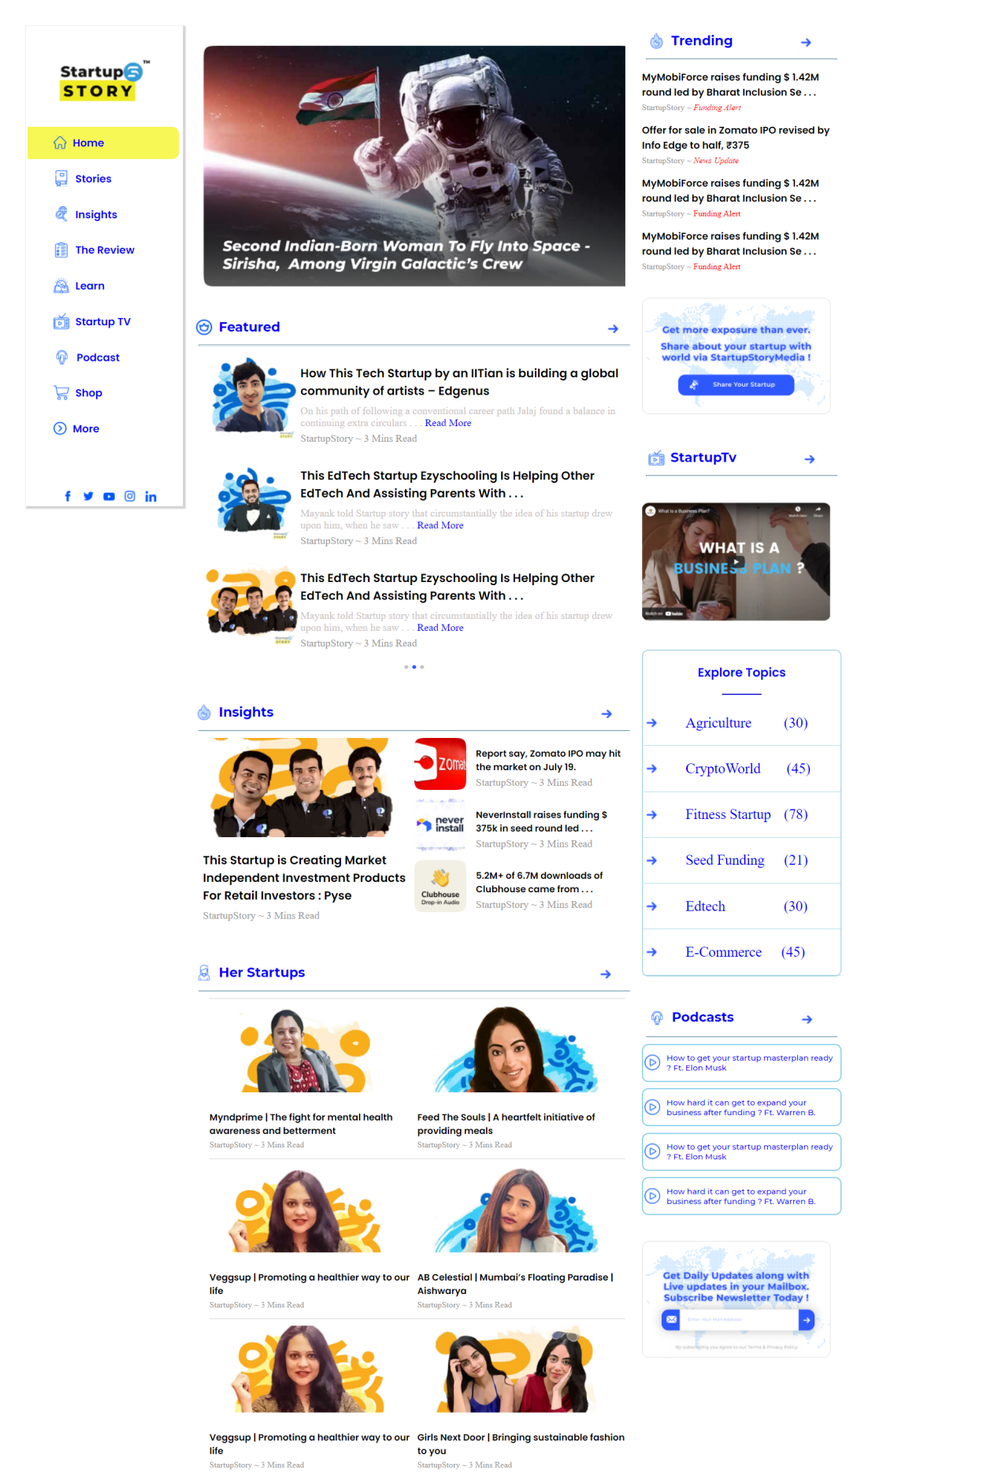

3rd page design

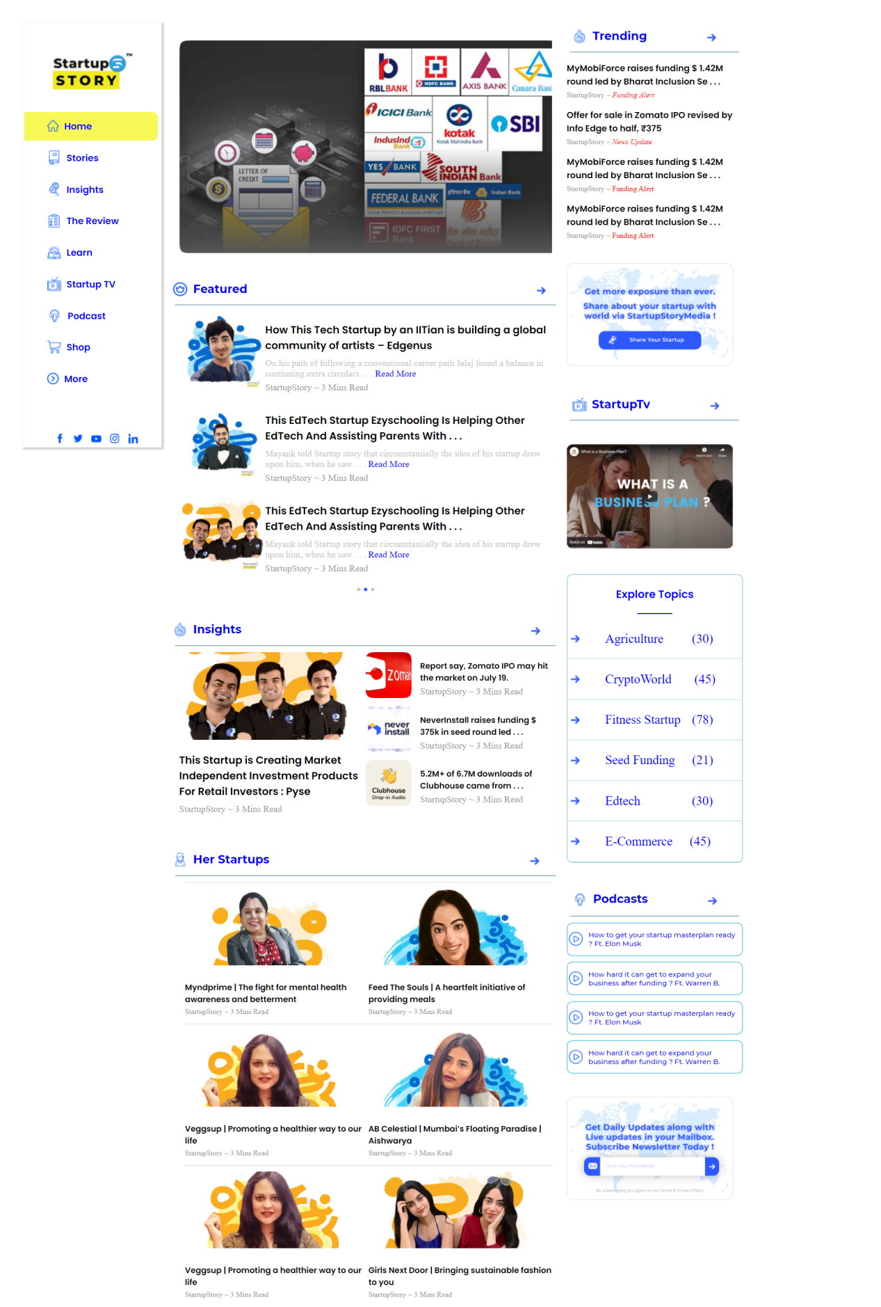

**1st page design code(index1.html)**

<!DOCTYPE html>

<html lang="en">

<head>

<meta charset="UTF-8">

<meta http-equiv="X-UA-Compatible" content="IE=edge">

<meta name="viewport" content="width=device-width, initial-scale=1.0">

<link rel="stylesheet" href="style.css">

<link rel="preconnect" href="https://fonts.googleapis.com">

<link rel="preconnect" href="https://fonts.gstatic.com" crossorigin>

<link href="https://fonts.googleapis.com/css2?family=Poppins:wght@600&display=swap" rel="stylesheet">

<link rel="preconnect" href="https://fonts.googleapis.com">

<link rel="preconnect" href="https://fonts.gstatic.com" crossorigin>

<link href="https://fonts.googleapis.com/css2?family=Montserrat:wght@500;700&display=swap" rel="stylesheet">

<title>Startup Story</title>

</head>

<body>

<!-- left side -->

<div class="left">

<div class="menu">

<div class="image">

<img src="./logo-2 1.png" class="imagee" alt="startup">

</div>

<div class="icon">

<div class="home same icon-left">

<div>

<img src="./logo/home.svg" class="logo" alt="home img"> </div>

Home </div>

<div class="stories same icon-left">

<div> <img src="./logo/stories.svg" class="logowh" alt="home img"> </div>

Stories</div>

<div class="insights same icon-left">

<div> <img src="./logo/insights.svg" class="logowh" alt="home img"> </div>

Insights</div>

<div class="review same icon-left">

<div> <img src="./logo/review.svg" class="logowh" alt="home img"> </div>

The Review</div>

<div class="learn same icon-left">

<div> <img src="./logo/learn.svg" class="logowh" alt="home img"> </div>

Learn</div>

<div class=" same icon-left">

<div> <img src="./logo/startup.svg" class="logowh" alt="home img"> </div>

Startup TV</div>

<div class="podcast same icon-left">

<div> <img src="./logo/poscast.svg" class="logowh" alt="home img"> </div>

Podcast</div>

<div class="shop same icon-left">

<div> <img src="./logo/shop.svg" class="logowh" alt="home img"> </div>

Shop</div>

<div class="more same icon-left">

<div> <img src="./logo/more.svg" class="logowh" alt="home img"> </div>

More</div>

</div>

<div class="sociallogo">

<div> <img src="./logo/fb.svg" class="sclogo" alt="home img"> </div>

<div> <img src="./logo/twitter.svg" class="sclogo" alt="home img"> </div>

<div> <img src="./logo/youtube.svg" class="sclogo" alt="home img"> </div>

<div> <img src="./logo/insta.svg" class="sclogo" alt="home img"> </div>

<div> <img src="./logo/linkedin.svg" class="sclogo" alt="home img"> </div>

</div>

</div>

</div>

<!-- center -->

<div class="center">

<div clas=image>

<img src="./logo/jeff.png" alt="image" class="jimg">

</div>

<div class="featured sidesp">

<div> <img src="./logo/featured.svg" class="feat" alt="home img"> </div>

Featured

<img src="./logo/arrow.svg" class="arw" alt="home img">

</div>

<hr class="sidesp" style="border-color: lightblue; width: 96%">

<div class="box ">

<div class="boxx ">

<div class="bimg ">

<img src="./logo/img1.png" alt="">

</div>

<div class="bcont">

<p class="headtext">How This Tech Startup by an IITian is building a global community of artists – Edgenus

</p>

<p class="text">On his path of following a conventional career path Jalaj found a balance in continuing extra circulars . . . <span style="color: blue;">Read More</span>

<br></p>

<p class="ltext">StartupStory ~ 3 Mins Read</p>

</div>

</div>

<div class="boxx ">

<div class="bimg ">

<img src="./logo/img2.png" alt="">

</div>

<div class="bcont">

<p class="headtext">This EdTech Startup Ezyschooling Is Helping Other EdTech And Assisting Parents With . . .

</p>

<p class="text">Mayank told Startup story that circumstantially the idea of his startup drew upon him, when he saw . . . <span style="color: blue;">Read More</span>

<br></p>

<p class="ltext">StartupStory ~ 3 Mins Read</p>

</div>

</div>

<div class="boxx ">

<div class="bimg ">

<img src="./logo/img3.png" alt="">

</div>

<div class="bcont">

<p class="headtext">This EdTech Startup Ezyschooling Is Helping Other EdTech And Assisting Parents With . . .

</p>

<p class="text">Mayank told Startup story that circumstantially the idea of his startup drew upon him, when he saw . . . <span style="color: blue;">Read More</span>

<br></p>

<p class="ltext">StartupStory ~ 3 Mins Read</p>

</div>

</div>

<div class="point">

<img src="./logo/point.svg" alt="">

</div>

</div>

<div class="featured sidesp">

<div> <img src="./logo/insight.svg" class="feat" alt="home img"> </div>

Insights

<img src="./logo/arrow.svg" class="arw" alt="home img">

</div>

<hr class="sidesp" style="border-color: lightblue; width: 96%">

<div class="box" style="display: flex;">

<div class="box1">

<img src="./logo/img4.png" alt="">

<p class="headtext">This Startup is Creating Market Independent Investment Products For Retail Investors : Pyse

</p>

<p class="ltext">StartupStory ~ 3 Mins Read</p>

</div>

<div class="box2">

<div class="bx">

<div class="bimg ">

<img src="./logo/zom.png" style="padding-right: 15px;" alt="">

</div>

<div class="bcont">

<p class="headtextx">Report say, Zomato IPO may hit the market on July 19.

</p>

<p class="ltext">StartupStory ~ 3 Mins Read</p>

</div>

</div>

<div class="bx">

<div class="bimg ">

<img src="./logo/nev.png" style="padding-right: 15px;" alt="">

</div>

<div class="bcont">

<p class="headtextx">NeverInstall raises funding $ 375k in seed round led . . .

</p>

<p class="ltext">StartupStory ~ 3 Mins Read</p>

</div>

</div>

<div class="bx">

<div class="bimg ">

<img src="./logo/club.png" style="padding-right: 15px;" alt="">

</div>

<div class="bcont">

<p class="headtextx">5.2M+ of 6.7M downloads of Clubhouse came from . . .

</p>

<p class="ltext">StartupStory ~ 3 Mins Read</p>

</div>

</div>

</div>

</div>

<div class="featured sidesp">

<div> <img src="./logo/her.svg" class="feat" alt="home img"> </div>

Her&nbspStartups

<img src="./logo/arrow.svg" class="arw1" alt="home img">

</div>

<hr class="sidesp" style="border-color: lightblue; width: 96%">

<div class="box">

<div class="bx1">

<div class="a1">

<div class="pic1"><img src="./logo/a1.png" class="pc" alt="home img"></div>

<div class="bcont">

<p class="headtextx">Myndprime | The fight for mental health awareness and betterment

</p>

<p class="ltext1">StartupStory ~ 3 Mins Read</p>

</div>

</div>

<div class="a2">

<div class="pic1"><img src="./logo/a2.png" class="pc" alt="home img"></div>

<div class="bcont">

<p class="headtextx">Feed The Souls | A heartfelt initiative of providing meals

</p>

<p class="ltext1">StartupStory ~ 3 Mins Read</p>

</div>

</div>

</div>

<div class="bx2">

<div class="a1">

<div class="pic1"><img src="./logo/a3.png" class="pc" alt="home img"></div>

<div class="bcont">

<p class="headtextx">Veggsup | Promoting a healthier way to our life

</p>

<p class="ltext1">StartupStory ~ 3 Mins Read</p>

</div>

</div>

<div class="a2">

<div class="pic1"><img src="./logo/a4.png" class="pc" alt="home img"></div>

<div class="bcont">

<p class="headtextx">AB Celestial | Mumbai’s Floating Paradise | Aishwarya

</p>

<p class="ltext1">StartupStory ~ 3 Mins Read</p>

</div>

</div>

</div>

<div class="bx3">

<div class="a1">

<div class="pic1"><img src="./logo/a5.png" class="pc" alt="home img"></div>

<div class="bcont">

<p class="headtextx">Veggsup | Promoting a healthier way to our life

</p>

<p class="ltext1">StartupStory ~ 3 Mins Read</p>

</div>

</div>

<div class="a2">

<div class="pic1"><img src="./logo/a6.png" class="pc" alt="home img"></div>

<div class="bcont">

<p class="headtextx">Girls Next Door | Bringing sustainable fashion to you

</p>

<p class="ltext1">StartupStory ~ 3 Mins Read</p>

</div>

</div>

</div>

</div>

</div>

<!-- right -->

<div class="right">

<div class="cont">

<div class="featured sidesp">

<div> <img src="./logo/insight.svg" class="feat" alt="home img"> </div>

Trending

<img src="./logo/arrow.svg" alt=" home img " style="margin-left: 100px;">

</div>

<hr class="sidesp " style="border-color: lightblue; width: 96% ">

</div>

<div class="artic">

<div class="art1">

<p class="headtext1">MyMobiForce raises funding $ 1.42M round led by Bharat Inclusion Se . . .

</p>

<p class="ltext1">StartupStory ~ <span style="color: red; font-style: italic;">Funding Alert</span></p>

</div>

<div class="art1">

<p class="headtext1">Offer for sale in Zomato IPO revised by Info Edge to half, ₹375

</p>

<p class="ltext1">StartupStory ~ <span style="color: red; font-style: italic;">News Update</span></p>

</div>

<div class="art1">

<p class="headtext1">MyMobiForce raises funding $ 1.42M round led by Bharat Inclusion Se . . .

</p>

<p class="ltext1">StartupStory ~ <span style="color: red;">Funding Alert</span></p>

</div>

<div class="art1">

<p class="headtext1">MyMobiForce raises funding $ 1.42M round led by Bharat Inclusion Se . . .

</p>

<p class="ltext1">StartupStory ~ <span style="color: red;">Funding Alert</span></p>

</div>

</div>

<div class="startup">

<img src="./logo/gp.png" alt="startup idea" class="stimg">

</div>

<div>

<div class="featured sidesp">

<div> <img src="./logo/startup.svg" class="feat" alt="home img"> </div>

StartupTv

<img src="./logo/arrow.svg" alt="home img" style=" margin-left: 100px;">

</div>

<hr class=" sidesp " style="border-color: lightblue; width: 96% ">

</div>

<div class="startup">

<img src="./logo/bus.png" alt="startup idea" class="stimg">

</div>

<div class="explore">

<div class="head">

<h3 style="text-align: center; color: blue; font-family: 'Poppins', sans-serif;;">Explore Topics</h3>

<hr style="width: 20%; border-color: blue;">

</div>

<div class="topics">

<img src="./logo/arrow.svg" alt=" home img " style="margin-right:40px;">

<p class="topicstyle">Agriculture</p>

<p style="color: blue; font-size: 22px; margin-left:50px; ">(30)</p>

</div>

<div class="topics ">

<img src="./logo/arrow.svg " alt=" home img " style="margin-right:40px; ">

<p class="topicstyle">CryptoWorld</p>

<p style="color: blue; font-size: 22px; margin-left:40px ; ">(45)</p>

</div>

<div class="topics ">

<img src="./logo/arrow.svg " alt=" home img " style="margin-right:40px; ">

<p class="topicstyle">Fitness Startup</p>

<p style="color: blue; font-size: 22px; margin-left:20px ; ">(78)</p>

</div>

<div class="topics ">

<img src="./logo/arrow.svg " alt=" home img " style="margin-right:40px; ">

<p class="topicstyle">Seed Funding</p>

<p style="color: blue; font-size: 22px; margin-left:30px ; ">(21)</p>

</div>

<div class="topics ">

<img src="./logo/arrow.svg " alt=" home img " style="margin-right:40px; ">

<p class="topicstyle">Edtech</p>

<p style="color: blue; font-size: 22px; margin-left:90px ; ">(30)</p>

</div>

<div class="topics ">

<img src="./logo/arrow.svg " alt=" home img " style="margin-right:40px; ">

<p class="topicstyle">E-Commerce</p>

<p style="color: blue; font-size: 22px; margin-left:30px ; ">(45)</p>

</div>

</div>

<div>

<div class="featured sidesp">

<div> <img src="./logo/poscast.svg" class="feat" alt="home img"> </div>

Podcasts

<img src="./logo/arrow.svg" alt=" home img " style="margin-left: 100px;">

</div>

<hr class="sidesp " style="border-color: lightblue; width: 96% ">

</div>

<div class="podcast">

<div class="detail">

<img src="./logo/vid.svg" alt="video" style="padding-right: 10px;">

<p>How to get your startup masterplan ready ? Ft. Elon Musk</p>

</div>

<div class="detail">

<img src="./logo/vid.svg" alt="video" style="padding-right: 10px;">

<p>How hard it can get to expand your business after funding ? Ft. Warren B.</p>

</div>

<div class="detail">

<img src="./logo/vid.svg" alt="video" style="padding-right: 10px;">

<p>How to get your startup masterplan ready ? Ft. Elon Musk</p>

</div>

<div class="detail">

<img src="./logo/vid.svg" alt="video" style="padding-right: 10px;">

<p>How hard it can get to expand your business after funding ? Ft. Warren B.</p>

</div>

</div>

<div class="startup">

<img src="./logo/gps.png" alt="startup idea" class="stimg">

</div>

</div>

</body>

</html>

**2nd page design code(index2.html)**

<!DOCTYPE html>

<html lang="en">

<head>

<meta charset="UTF-8">

<meta http-equiv="X-UA-Compatible" content="IE=edge">

<meta name="viewport" content="width=device-width, initial-scale=1.0">

<link rel="stylesheet" href="style.css">

<link rel="preconnect" href="https://fonts.googleapis.com">

<link rel="preconnect" href="https://fonts.gstatic.com" crossorigin>

<link href="https://fonts.googleapis.com/css2?family=Poppins:wght@600&display=swap" rel="stylesheet">

<link rel="preconnect" href="https://fonts.googleapis.com">

<link rel="preconnect" href="https://fonts.gstatic.com" crossorigin>

<link href="https://fonts.googleapis.com/css2?family=Montserrat:wght@500;700&display=swap" rel="stylesheet">

<title>Startup Story</title>

</head>

<body>

<!-- left side -->

<div class="left">

<div class="menu">

<div class="image">

<img src="./logo-2 1.png" class="imagee" alt="startup">

</div>

<div class="icon">

<div class="home same icon-left">

<div>

<img src="./logo/home.svg" class="logo" alt="home img"> </div>

Home </div>

<div class="stories same icon-left">

<div> <img src="./logo/stories.svg" class="logowh" alt="home img"> </div>

Stories</div>

<div class="insights same icon-left">

<div> <img src="./logo/insights.svg" class="logowh" alt="home img"> </div>

Insights</div>

<div class="review same icon-left">

<div> <img src="./logo/review.svg" class="logowh" alt="home img"> </div>

The Review</div>

<div class="learn same icon-left">

<div> <img src="./logo/learn.svg" class="logowh" alt="home img"> </div>

Learn</div>

<div class=" same icon-left">

<div> <img src="./logo/startup.svg" class="logowh" alt="home img"> </div>

Startup TV</div>

<div class="podcast same icon-left">

<div> <img src="./logo/poscast.svg" class="logowh" alt="home img"> </div>

Podcast</div>

<div class="shop same icon-left">

<div> <img src="./logo/shop.svg" class="logowh" alt="home img"> </div>

Shop</div>

<div class="more same icon-left">

<div> <img src="./logo/more.svg" class="logowh" alt="home img"> </div>

More</div>

</div>

<div class="sociallogo">

<div> <img src="./logo/fb.svg" class="sclogo" alt="home img"> </div>

<div> <img src="./logo/twitter.svg" class="sclogo" alt="home img"> </div>

<div> <img src="./logo/youtube.svg" class="sclogo" alt="home img"> </div>

<div> <img src="./logo/insta.svg" class="sclogo" alt="home img"> </div>

<div> <img src="./logo/linkedin.svg" class="sclogo" alt="home img"> </div>

</div>

</div>

</div>

<!-- center -->

<div class="center">

<div clas=image>

<img src="./logo/second.png" alt="image" class="jimg">

</div>

<div class="featured sidesp">

<div> <img src="./logo/featured.svg" class="feat" alt="home img"> </div>

Featured

<img src="./logo/arrow.svg" class="arw" alt="home img">

</div>

<hr class="sidesp" style="border-color: lightblue; width: 96%">

<div class="box ">

<div class="boxx ">

<div class="bimg ">

<img src="./logo/img1.png" alt="">

</div>

<div class="bcont">

<p class="headtext">How This Tech Startup by an IITian is building a global community of artists – Edgenus

</p>

<p class="text">On his path of following a conventional career path Jalaj found a balance in continuing extra circulars . . . <span style="color: blue;">Read More</span>

<br></p>

<p class="ltext">StartupStory ~ 3 Mins Read</p>

</div>

</div>

<div class="boxx ">

<div class="bimg ">

<img src="./logo/img2.png" alt="">

</div>

<div class="bcont">

<p class="headtext">This EdTech Startup Ezyschooling Is Helping Other EdTech And Assisting Parents With . . .

</p>

<p class="text">Mayank told Startup story that circumstantially the idea of his startup drew upon him, when he saw . . . <span style="color: blue;">Read More</span>

<br></p>

<p class="ltext">StartupStory ~ 3 Mins Read</p>

</div>

</div>

<div class="boxx ">

<div class="bimg ">

<img src="./logo/img3.png" alt="">

</div>

<div class="bcont">

<p class="headtext">This EdTech Startup Ezyschooling Is Helping Other EdTech And Assisting Parents With . . .

</p>

<p class="text">Mayank told Startup story that circumstantially the idea of his startup drew upon him, when he saw . . . <span style="color: blue;">Read More</span>

<br></p>

<p class="ltext">StartupStory ~ 3 Mins Read</p>

</div>

</div>

<div class="point">

<img src="./logo/point.svg" alt="">

</div>

</div>

<div class="featured sidesp">

<div> <img src="./logo/insight.svg" class="feat" alt="home img"> </div>

Insights

<img src="./logo/arrow.svg" class="arw" alt="home img">

</div>

<hr class="sidesp" style="border-color: lightblue; width: 96%">

<div class="box" style="display: flex;">

<div class="box1">

<img src="./logo/img4.png" alt="">

<p class="headtext">This Startup is Creating Market Independent Investment Products For Retail Investors : Pyse

</p>

<p class="ltext">StartupStory ~ 3 Mins Read</p>

</div>

<div class="box2">

<div class="bx">

<div class="bimg ">

<img src="./logo/zom.png" style="padding-right: 15px;" alt="">

</div>

<div class="bcont">

<p class="headtextx">Report say, Zomato IPO may hit the market on July 19.

</p>

<p class="ltext">StartupStory ~ 3 Mins Read</p>

</div>

</div>

<div class="bx">

<div class="bimg ">

<img src="./logo/nev.png" style="padding-right: 15px;" alt="">

</div>

<div class="bcont">

<p class="headtextx">NeverInstall raises funding $ 375k in seed round led . . .

</p>

<p class="ltext">StartupStory ~ 3 Mins Read</p>

</div>

</div>

<div class="bx">

<div class="bimg ">

<img src="./logo/club.png" style="padding-right: 15px;" alt="">

</div>

<div class="bcont">

<p class="headtextx">5.2M+ of 6.7M downloads of Clubhouse came from . . .

</p>

<p class="ltext">StartupStory ~ 3 Mins Read</p>

</div>

</div>

</div>

</div>

<div class="featured sidesp">

<div> <img src="./logo/her.svg" class="feat" alt="home img"> </div>

Her&nbspStartups

<img src="./logo/arrow.svg" class="arw1" alt="home img">

</div>

<hr class="sidesp" style="border-color: lightblue; width: 96%">

<div class="box">

<div class="bx1">

<div class="a1">

<div class="pic1"><img src="./logo/a1.png" class="pc" alt="home img"></div>

<div class="bcont">

<p class="headtextx">Myndprime | The fight for mental health awareness and betterment

</p>

<p class="ltext1">StartupStory ~ 3 Mins Read</p>

</div>

</div>

<div class="a2">

<div class="pic1"><img src="./logo/a2.png" class="pc" alt="home img"></div>

<div class="bcont">

<p class="headtextx">Feed The Souls | A heartfelt initiative of providing meals

</p>

<p class="ltext1">StartupStory ~ 3 Mins Read</p>

</div>

</div>

</div>

<div class="bx2">

<div class="a1">

<div class="pic1"><img src="./logo/a3.png" class="pc" alt="home img"></div>

<div class="bcont">

<p class="headtextx">Veggsup | Promoting a healthier way to our life

</p>

<p class="ltext1">StartupStory ~ 3 Mins Read</p>

</div>

</div>

<div class="a2">

<div class="pic1"><img src="./logo/a4.png" class="pc" alt="home img"></div>

<div class="bcont">

<p class="headtextx">AB Celestial | Mumbai’s Floating Paradise | Aishwarya

</p>

<p class="ltext1">StartupStory ~ 3 Mins Read</p>

</div>

</div>

</div>

<div class="bx3">

<div class="a1">

<div class="pic1"><img src="./logo/a5.png" class="pc" alt="home img"></div>

<div class="bcont">

<p class="headtextx">Veggsup | Promoting a healthier way to our life

</p>

<p class="ltext1">StartupStory ~ 3 Mins Read</p>

</div>

</div>

<div class="a2">

<div class="pic1"><img src="./logo/a6.png" class="pc" alt="home img"></div>

<div class="bcont">

<p class="headtextx">Girls Next Door | Bringing sustainable fashion to you

</p>

<p class="ltext1">StartupStory ~ 3 Mins Read</p>

</div>

</div>

</div>

</div>

</div>

<!-- right -->

<div class="right">

<div class="cont">

<div class="featured sidesp">

<div> <img src="./logo/insight.svg" class="feat" alt="home img"> </div>

Trending

<img src="./logo/arrow.svg" alt=" home img " style="margin-left: 100px;">

</div>

<hr class="sidesp " style="border-color: lightblue; width: 96% ">

</div>

<div class="artic">

<div class="art1">

<p class="headtext1">MyMobiForce raises funding $ 1.42M round led by Bharat Inclusion Se . . .

</p>

<p class="ltext1">StartupStory ~ <span style="color: red; font-style: italic;">Funding Alert</span></p>

</div>

<div class="art1">

<p class="headtext1">Offer for sale in Zomato IPO revised by Info Edge to half, ₹375

</p>

<p class="ltext1">StartupStory ~ <span style="color: red; font-style: italic;">News Update</span></p>

</div>

<div class="art1">

<p class="headtext1">MyMobiForce raises funding $ 1.42M round led by Bharat Inclusion Se . . .

</p>

<p class="ltext1">StartupStory ~ <span style="color: red;">Funding Alert</span></p>

</div>

<div class="art1">

<p class="headtext1">MyMobiForce raises funding $ 1.42M round led by Bharat Inclusion Se . . .

</p>

<p class="ltext1">StartupStory ~ <span style="color: red;">Funding Alert</span></p>

</div>

</div>

<div class="startup">

<img src="./logo/gp.png" alt="startup idea" class="stimg">

</div>

<div>

<div class="featured sidesp">

<div> <img src="./logo/startup.svg" class="feat" alt="home img"> </div>

StartupTv

<img src="./logo/arrow.svg" alt="home img" style=" margin-left: 100px;">

</div>

<hr class=" sidesp " style="border-color: lightblue; width: 96% ">

</div>

<div class="startup">

<img src="./logo/bus.png" alt="startup idea" class="stimg">

</div>

<div class="explore">

<div class="head">

<h3 style="text-align: center; color: blue; font-family: 'Poppins', sans-serif;;">Explore Topics</h3>

<hr style="width: 20%; border-color: blue;">

</div>

<div class="topics">

<img src="./logo/arrow.svg" alt=" home img " style="margin-right:40px;">

<p class="topicstyle">Agriculture</p>

<p style="color: blue; font-size: 22px; margin-left:50px; ">(30)</p>

</div>

<div class="topics ">

<img src="./logo/arrow.svg " alt=" home img " style="margin-right:40px; ">

<p class="topicstyle">CryptoWorld</p>

<p style="color: blue; font-size: 22px; margin-left:40px ; ">(45)</p>

</div>

<div class="topics ">

<img src="./logo/arrow.svg " alt=" home img " style="margin-right:40px; ">

<p class="topicstyle">Fitness Startup</p>

<p style="color: blue; font-size: 22px; margin-left:20px ; ">(78)</p>

</div>

<div class="topics ">

<img src="./logo/arrow.svg " alt=" home img " style="margin-right:40px; ">

<p class="topicstyle">Seed Funding</p>

<p style="color: blue; font-size: 22px; margin-left:30px ; ">(21)</p>

</div>

<div class="topics ">

<img src="./logo/arrow.svg " alt=" home img " style="margin-right:40px; ">

<p class="topicstyle">Edtech</p>

<p style="color: blue; font-size: 22px; margin-left:90px ; ">(30)</p>

</div>

<div class="topics ">

<img src="./logo/arrow.svg " alt=" home img " style="margin-right:40px; ">

<p class="topicstyle">E-Commerce</p>

<p style="color: blue; font-size: 22px; margin-left:30px ; ">(45)</p>

</div>

</div>

<div>

<div class="featured sidesp">

<div> <img src="./logo/poscast.svg" class="feat" alt="home img"> </div>

Podcasts

<img src="./logo/arrow.svg" alt=" home img " style="margin-left: 100px;">

</div>

<hr class="sidesp " style="border-color: lightblue; width: 96% ">

</div>

<div class="podcast">

<div class="detail">

<img src="./logo/vid.svg" alt="video" style="padding-right: 10px;">

<p>How to get your startup masterplan ready ? Ft. Elon Musk</p>

</div>

<div class="detail">

<img src="./logo/vid.svg" alt="video" style="padding-right: 10px;">

<p>How hard it can get to expand your business after funding ? Ft. Warren B.</p>

</div>

<div class="detail">

<img src="./logo/vid.svg" alt="video" style="padding-right: 10px;">

<p>How to get your startup masterplan ready ? Ft. Elon Musk</p>

</div>

<div class="detail">

<img src="./logo/vid.svg" alt="video" style="padding-right: 10px;">

<p>How hard it can get to expand your business after funding ? Ft. Warren B.</p>

</div>

</div>

<div class="startup">

<img src="./logo/gps.png" alt="startup idea" class="stimg">

</div>

</div>

</body>

</html>

**3rd page design code(index3.html)**

<!DOCTYPE html>

<html lang="en">

<head>

<meta charset="UTF-8">

<meta http-equiv="X-UA-Compatible" content="IE=edge">

<meta name="viewport" content="width=device-width, initial-scale=1.0">

<link rel="stylesheet" href="style.css">

<link rel="preconnect" href="https://fonts.googleapis.com">

<link rel="preconnect" href="https://fonts.gstatic.com" crossorigin>

<link href="https://fonts.googleapis.com/css2?family=Poppins:wght@600&display=swap" rel="stylesheet">

<link rel="preconnect" href="https://fonts.googleapis.com">

<link rel="preconnect" href="https://fonts.gstatic.com" crossorigin>

<link href="https://fonts.googleapis.com/css2?family=Montserrat:wght@500;700&display=swap" rel="stylesheet">

<title>Startup Story</title>

</head>

<body>

<!-- left side -->

<div class="left">

<div class="menu">

<div class="image">

<img src="./logo-2 1.png" class="imagee" alt="startup">

</div>

<div class="icon">

<div class="home same icon-left">

<div>

<img src="./logo/home.svg" class="logo" alt="home img"> </div>

Home </div>

<div class="stories same icon-left">

<div> <img src="./logo/stories.svg" class="logowh" alt="home img"> </div>

Stories</div>

<div class="insights same icon-left">

<div> <img src="./logo/insights.svg" class="logowh" alt="home img"> </div>

Insights</div>

<div class="review same icon-left">

<div> <img src="./logo/review.svg" class="logowh" alt="home img"> </div>

The Review</div>

<div class="learn same icon-left">

<div> <img src="./logo/learn.svg" class="logowh" alt="home img"> </div>

Learn</div>

<div class=" same icon-left">

<div> <img src="./logo/startup.svg" class="logowh" alt="home img"> </div>

Startup TV</div>

<div class="podcast same icon-left">

<div> <img src="./logo/poscast.svg" class="logowh" alt="home img"> </div>

Podcast</div>

<div class="shop same icon-left">

<div> <img src="./logo/shop.svg" class="logowh" alt="home img"> </div>

Shop</div>

<div class="more same icon-left">

<div> <img src="./logo/more.svg" class="logowh" alt="home img"> </div>

More</div>

</div>

<div class="sociallogo">

<div> <img src="./logo/fb.svg" class="sclogo" alt="home img"> </div>

<div> <img src="./logo/twitter.svg" class="sclogo" alt="home img"> </div>

<div> <img src="./logo/youtube.svg" class="sclogo" alt="home img"> </div>

<div> <img src="./logo/insta.svg" class="sclogo" alt="home img"> </div>

<div> <img src="./logo/linkedin.svg" class="sclogo" alt="home img"> </div>

</div>

</div>

</div>

<!-- center -->

<div class="center">

<div clas=image>

<img src="./logo/third.png" alt="image" class="jimg">

</div>

<div class="featured sidesp">

<div> <img src="./logo/featured.svg" class="feat" alt="home img"> </div>

Featured

<img src="./logo/arrow.svg" class="arw" alt="home img">

</div>

<hr class="sidesp" style="border-color: lightblue; width: 96%">

<div class="box ">

<div class="boxx ">

<div class="bimg ">

<img src="./logo/img1.png" alt="">

</div>

<div class="bcont">

<p class="headtext">How This Tech Startup by an IITian is building a global community of artists – Edgenus

</p>

<p class="text">On his path of following a conventional career path Jalaj found a balance in continuing extra circulars . . . <span style="color: blue;">Read More</span>

<br></p>

<p class="ltext">StartupStory ~ 3 Mins Read</p>

</div>

</div>

<div class="boxx ">

<div class="bimg ">

<img src="./logo/img2.png" alt="">

</div>

<div class="bcont">

<p class="headtext">This EdTech Startup Ezyschooling Is Helping Other EdTech And Assisting Parents With . . .

</p>

<p class="text">Mayank told Startup story that circumstantially the idea of his startup drew upon him, when he saw . . . <span style="color: blue;">Read More</span>

<br></p>

<p class="ltext">StartupStory ~ 3 Mins Read</p>

</div>

</div>

<div class="boxx ">

<div class="bimg ">

<img src="./logo/img3.png" alt="">

</div>

<div class="bcont">

<p class="headtext">This EdTech Startup Ezyschooling Is Helping Other EdTech And Assisting Parents With . . .

</p>

<p class="text">Mayank told Startup story that circumstantially the idea of his startup drew upon him, when he saw . . . <span style="color: blue;">Read More</span>

<br></p>

<p class="ltext">StartupStory ~ 3 Mins Read</p>

</div>

</div>

<div class="point">

<img src="./logo/point.svg" alt="">

</div>

</div>

<div class="featured sidesp">

<div> <img src="./logo/insight.svg" class="feat" alt="home img"> </div>

Insights

<img src="./logo/arrow.svg" class="arw" alt="home img">

</div>

<hr class="sidesp" style="border-color: lightblue; width: 96%">

<div class="box" style="display: flex;">

<div class="box1">

<img src="./logo/img4.png" alt="">

<p class="headtext">This Startup is Creating Market Independent Investment Products For Retail Investors : Pyse

</p>

<p class="ltext">StartupStory ~ 3 Mins Read</p>

</div>

<div class="box2">

<div class="bx">

<div class="bimg ">

<img src="./logo/zom.png" style="padding-right: 15px;" alt="">

</div>

<div class="bcont">

<p class="headtextx">Report say, Zomato IPO may hit the market on July 19.

</p>

<p class="ltext">StartupStory ~ 3 Mins Read</p>

</div>

</div>

<div class="bx">

<div class="bimg ">

<img src="./logo/nev.png" style="padding-right: 15px;" alt="">

</div>

<div class="bcont">

<p class="headtextx">NeverInstall raises funding $ 375k in seed round led . . .

</p>

<p class="ltext">StartupStory ~ 3 Mins Read</p>

</div>

</div>

<div class="bx">

<div class="bimg ">

<img src="./logo/club.png" style="padding-right: 15px;" alt="">

</div>

<div class="bcont">

<p class="headtextx">5.2M+ of 6.7M downloads of Clubhouse came from . . .

</p>

<p class="ltext">StartupStory ~ 3 Mins Read</p>

</div>

</div>

</div>

</div>

<div class="featured sidesp">

<div> <img src="./logo/her.svg" class="feat" alt="home img"> </div>

Her&nbspStartups

<img src="./logo/arrow.svg" class="arw1" alt="home img">

</div>

<hr class="sidesp" style="border-color: lightblue; width: 96%">

<div class="box">

<div class="bx1">

<div class="a1">

<div class="pic1"><img src="./logo/a1.png" class="pc" alt="home img"></div>

<div class="bcont">

<p class="headtextx">Myndprime | The fight for mental health awareness and betterment

</p>

<p class="ltext1">StartupStory ~ 3 Mins Read</p>

</div>

</div>

<div class="a2">

<div class="pic1"><img src="./logo/a2.png" class="pc" alt="home img"></div>

<div class="bcont">

<p class="headtextx">Feed The Souls | A heartfelt initiative of providing meals

</p>

<p class="ltext1">StartupStory ~ 3 Mins Read</p>

</div>

</div>

</div>

<div class="bx2">

<div class="a1">

<div class="pic1"><img src="./logo/a3.png" class="pc" alt="home img"></div>

<div class="bcont">

<p class="headtextx">Veggsup | Promoting a healthier way to our life

</p>

<p class="ltext1">StartupStory ~ 3 Mins Read</p>

</div>

</div>

<div class="a2">

<div class="pic1"><img src="./logo/a4.png" class="pc" alt="home img"></div>

<div class="bcont">

<p class="headtextx">AB Celestial | Mumbai’s Floating Paradise | Aishwarya

</p>

<p class="ltext1">StartupStory ~ 3 Mins Read</p>

</div>

</div>

</div>

<div class="bx3">

<div class="a1">

<div class="pic1"><img src="./logo/a5.png" class="pc" alt="home img"></div>

<div class="bcont">

<p class="headtextx">Veggsup | Promoting a healthier way to our life

</p>

<p class="ltext1">StartupStory ~ 3 Mins Read</p>

</div>

</div>

<div class="a2">

<div class="pic1"><img src="./logo/a6.png" class="pc" alt="home img"></div>

<div class="bcont">

<p class="headtextx">Girls Next Door | Bringing sustainable fashion to you

</p>

<p class="ltext1">StartupStory ~ 3 Mins Read</p>

</div>

</div>

</div>

</div>

</div>

<!-- right -->

<div class="right">

<div class="cont">

<div class="featured sidesp">

<div> <img src="./logo/insight.svg" class="feat" alt="home img"> </div>

Trending

<img src="./logo/arrow.svg" alt=" home img " style="margin-left: 100px;">

</div>

<hr class="sidesp " style="border-color: lightblue; width: 96% ">

</div>

<div class="artic">

<div class="art1">

<p class="headtext1">MyMobiForce raises funding $ 1.42M round led by Bharat Inclusion Se . . .

</p>

<p class="ltext1">StartupStory ~ <span style="color: red; font-style: italic;">Funding Alert</span></p>

</div>

<div class="art1">

<p class="headtext1">Offer for sale in Zomato IPO revised by Info Edge to half, ₹375

</p>

<p class="ltext1">StartupStory ~ <span style="color: red; font-style: italic;">News Update</span></p>

</div>

<div class="art1">

<p class="headtext1">MyMobiForce raises funding $ 1.42M round led by Bharat Inclusion Se . . .

</p>

<p class="ltext1">StartupStory ~ <span style="color: red;">Funding Alert</span></p>

</div>

<div class="art1">

<p class="headtext1">MyMobiForce raises funding $ 1.42M round led by Bharat Inclusion Se . . .

</p>

<p class="ltext1">StartupStory ~ <span style="color: red;">Funding Alert</span></p>

</div>

</div>

<div class="startup">

<img src="./logo/gp.png" alt="startup idea" class="stimg">

</div>

<div>

<div class="featured sidesp">

<div> <img src="./logo/startup.svg" class="feat" alt="home img"> </div>

StartupTv

<img src="./logo/arrow.svg" alt="home img" style=" margin-left: 100px;">

</div>

<hr class=" sidesp " style="border-color: lightblue; width: 96% ">

</div>

<div class="startup">

<img src="./logo/bus.png" alt="startup idea" class="stimg">

</div>

<div class="explore">

<div class="head">

<h3 style="text-align: center; color: blue; font-family: 'Poppins', sans-serif;;">Explore Topics</h3>

<hr style="width: 20%; border-color: blue;">

</div>

<div class="topics">

<img src="./logo/arrow.svg" alt=" home img " style="margin-right:40px;">

<p class="topicstyle">Agriculture</p>

<p style="color: blue; font-size: 22px; margin-left:50px; ">(30)</p>

</div>

<div class="topics ">

<img src="./logo/arrow.svg " alt=" home img " style="margin-right:40px; ">

<p class="topicstyle">CryptoWorld</p>

<p style="color: blue; font-size: 22px; margin-left:40px ; ">(45)</p>

</div>

<div class="topics ">

<img src="./logo/arrow.svg " alt=" home img " style="margin-right:40px; ">

<p class="topicstyle">Fitness Startup</p>

<p style="color: blue; font-size: 22px; margin-left:20px ; ">(78)</p>

</div>

<div class="topics ">

<img src="./logo/arrow.svg " alt=" home img " style="margin-right:40px; ">

<p class="topicstyle">Seed Funding</p>

<p style="color: blue; font-size: 22px; margin-left:30px ; ">(21)</p>

</div>

<div class="topics ">

<img src="./logo/arrow.svg " alt=" home img " style="margin-right:40px; ">

<p class="topicstyle">Edtech</p>

<p style="color: blue; font-size: 22px; margin-left:90px ; ">(30)</p>

</div>

<div class="topics ">

<img src="./logo/arrow.svg " alt=" home img " style="margin-right:40px; ">

<p class="topicstyle">E-Commerce</p>

<p style="color: blue; font-size: 22px; margin-left:30px ; ">(45)</p>

</div>

</div>

<div>

<div class="featured sidesp">

<div> <img src="./logo/poscast.svg" class="feat" alt="home img"> </div>

Podcasts

<img src="./logo/arrow.svg" alt=" home img " style="margin-left: 100px;">

</div>

<hr class="sidesp " style="border-color: lightblue; width: 96% ">

</div>

<div class="podcast">

<div class="detail">

<img src="./logo/vid.svg" alt="video" style="padding-right: 10px;">

<p>How to get your startup masterplan ready ? Ft. Elon Musk</p>

</div>

<div class="detail">

<img src="./logo/vid.svg" alt="video" style="padding-right: 10px;">

<p>How hard it can get to expand your business after funding ? Ft. Warren B.</p>

</div>

<div class="detail">

<img src="./logo/vid.svg" alt="video" style="padding-right: 10px;">

<p>How to get your startup masterplan ready ? Ft. Elon Musk</p>

</div>

<div class="detail">

<img src="./logo/vid.svg" alt="video" style="padding-right: 10px;">

<p>How hard it can get to expand your business after funding ? Ft. Warren B.</p>

</div>

</div>

<div class="startup">

<img src="./logo/gps.png" alt="startup idea" class="stimg">

</div>

</div>

</body>

</html>

**CSS Code**

body {

margin: 0;

padding: 0;

/* background-color: rgb(300, 300, 300); */

background-color: whitesmoke;

}

* {

box-sizing: border-box;

}

.left {

padding-left: 40px;

padding-right: 10px;

padding-top: 40px;

width: 19%;

height: 100%;

float: left;

background-color: E5E5E5;

}

.same {

font-size: 16px;

margin: 5px;

color: blue;

font-family: 'Poppins', sans-serif;

margin-left: 0%;

height: 50px;

text-align: center;

display: flex;

justify-content: left;

align-items: center;

}

.home {

background-color: rgb(247, 247, 85);

border-radius: 0 10px 10px 0;

padding-left: 0px;

}

.logo {

padding-right: 10px;

background-color: rgb(247, 247, 85);

padding-top: 5px;

}

.logowh {

padding-right: 10px;

background-color: white;

padding-top: 5px;

}

.icon-left {

padding-left: 40px;

}

.icon {

padding-top: 20px;

}

/* .imagee {

width: 100px;

height: 100px;

background: transparent;

overflow: hidden;

} */

.sociallogo {

display: flex;

justify-content: center;

align-items: center;

margin-top: 70px;

}

.sclogo {

padding-left: 15px;

}

.menu {

border: 2px solid white;

height: auto;

padding-top: 40px;

text-align: center;

box-shadow: 2px 2px 2px 2px lightgrey;

background-color: #ffffff;

}

/* center */

.center {

float: left;

width: 45%;

height: auto;

background-color: white;

margin-right: 5px;

}

.sidesp {

margin-left: auto;

margin-right: auto;

}

.jimg {

display: block;

margin-left: auto;

margin-right: auto;

width: 650px;

height: auto;

margin-top: 70px;

}

.featured {

margin-top: 40px;

width: auto;

color: blue;

font-size: 20px;

font-weight: bold;

font-family: 'Montserrat', sans-serif;

display: flex;

padding: 10px;

float: left;

}

.arw {

padding-left: 500px;

}

.arw1 {

padding-left: 450px;

}

.feat {

margin-right: 10px;

}

.box {

display: block;

margin-left: auto;

margin-right: auto;

width: 650px;

height: auto;

margin-top: 10px;

/* border: 2px solid black; */

}

.boxx {

display: flex;

}

.box1 {

width: 50%;

}

.box2 {

width: 50%;

}

.bx {

display: flex;

}

.headtext {

font-size: 18px;

font-weight: bold;

font-family: 'Poppins', sans-serif;

}

.headtextx {

font-size: 14px;

font-weight: bold;

font-family: 'Poppins', sans-serif;

}

.text {

margin-top: -10px;

color: rgb(204, 197, 197);

}

.ltext {

margin-top: -10px;

color: rgb(153, 151, 151);

}

.ltext1 {

margin-top: -10px;

color: rgb(153, 151, 151);

font-size: 13px;

}

.point {

text-align: center;

}

.bx1 {

/* border: 2px solid black; */

display: flex;

}

.bx2 {

/* border: 2px solid black; */

display: flex;

}

.bx3 {

/* border: 2px solid black; */

display: flex;

}

.a1 {

width: 50%;

border-top: 1px solid lightgray;

margin-left: 10px;

}

.a2 {

width: 50%;

border-top: 1px solid lightgray;

}

.pc {

padding: 10px;

width: 300px;

height: auto;

}

/* .............. */

/* right */

.right {

float: left;

width: 20%;

background-color: #ffffff;

/* border: 2px solid black; */

height: auto;

}

.artic {

margin-top: 10px;

margin-left: auto;

margin-right: auto;

}

.headtext1 {

font-size: 15px;

font-weight: bold;

font-family: 'Poppins', sans-serif;

}

.startup {

margin-top: 40px;

margin-left: auto;

margin-right: auto;

}

.stimg {

width: 290px;

height: auto;

}

.explore {

margin-top: 40px;

border: 2px solid lightblue;

border-radius: 10px;

}

.topics {

display: flex;

border-bottom: 1px solid lightblue;

}

.topicstyle {

color: blue;

font-size: 22px;

}

.detail {

display: flex;

border: 2px solid rgb(128, 205, 231);

border-radius: 10px;

font-size: 12px;

color: blue;

padding-left: 2px;

padding-right: 2px;

font-family: 'Montserrat', sans-serif;

margin-right: auto;

margin-left: auto;

margin-top: 10px;

}